3-Node Kafka KRaft Cluster (Single VM)
Kafka Version: 4.1.1
Java Version: 17+
Mode: KRaft (no ZooKeeper)
Setup: 3 brokers + 3 controllers (combined mode)

Step-1: System Preparation
Update system:
sudo yum update -y
Install Java 17 (required by Kafka 4.x):
sudo yum install java-17-amazon-corretto -y
java -version
Expected output: Java 17

Step-2: Kafka Installation
Download Kafka 4.1.1:
cd /opt
sudo wget https://downloads.apache.org/kafka/4.1.1/kafka_2.13-4.1.1.tgz
sudo tar -xzf kafka_2.13-4.1.1.tgz
sudo mv kafka_2.13-4.1.1 kafka
sudo chown -R ec2-user:ec2-user kafka
cd kafka
ls
You should see:
bin config libs licenses site-docs

Step-3: Create Data Directories
Kafka stores data per broker. Create separate folders:
sudo mkdir -p /data/kafka1 /data/kafka2 /data/kafka3
sudo chown -R ec2-user:ec2-user /data
Why?
Each broker must have its own log directory to avoid data corruption.

Step-4: Create Config Files
Copy the default server.properties to 3 configs:
cd /opt/kafka/config
cp server.properties server1.properties
cp server.properties server2.properties
cp server.properties server3.properties

Step-5: Configure Brokers
server1.properties
process.roles=broker,controller
node.id=1

controller.quorum.voters=1@localhost:9093,2@localhost:9095,3@localhost:9097

listeners=PLAINTEXT://:9092,CONTROLLER://:9093
advertised.listeners=PLAINTEXT://localhost:9092

inter.broker.listener.name=PLAINTEXT
controller.listener.names=CONTROLLER

listener.security.protocol.map=CONTROLLER:PLAINTEXT,PLAINTEXT:PLAINTEXT

log.dirs=/data/kafka1

offsets.topic.replication.factor=3
transaction.state.log.replication.factor=3
transaction.state.log.min.isr=2

server2.properties
process.roles=broker,controller
node.id=2

controller.quorum.voters=1@localhost:9093,2@localhost:9095,3@localhost:9097

listeners=PLAINTEXT://:9094,CONTROLLER://:9095
advertised.listeners=PLAINTEXT://localhost:9094

inter-broker.listener.name=PLAINTEXT
controller.listener.names=CONTROLLER

listener.security.protocol.map=CONTROLLER:PLAINTEXT,PLAINTEXT:PLAINTEXT

log.dirs=/data/kafka2

offsets.topic.replication.factor=3
transaction.state.log.replication.factor=3
transaction.state.log.min.isr=2

server3.properties
process.roles=broker,controller
node.id=3

controller.quorum.voters=1@localhost:9093,2@localhost:9095,3@localhost:9097

listeners=PLAINTEXT://:9096,CONTROLLER://:9097
advertised.listeners=PLAINTEXT://localhost:9096

inter-broker.listener.name=PLAINTEXT
controller.listener.names=CONTROLLER

listener.security.protocol.map=CONTROLLER:PLAINTEXT,PLAINTEXT:PLAINTEXT

log.dirs=/data/kafka3

offsets.topic.replication.factor=3
transaction.state.log.replication.factor=3
transaction.state.log.min.isr=2

Explanation of Key Properties
Property | Purpose
process.roles | Node roles: broker + controller
node.id | Unique node identifier (1,2,3)
controller.quorum.voters | Raft quorum nodes (format: id@host:port)
listeners | Ports Kafka binds for client & controller traffic
advertised.listeners | Address advertised to clients
inter-broker.listener.name | Listener used for replication between brokers
controller.listener.names | Controller communication listener
listener.security.protocol.map | Protocol mapping per listener
log.dirs | Data storage folder
offsets.topic.replication.factor | Replication factor for consumer offsets
transaction.state.log.replication.factor | Replication for transactions
transaction.state.log.min.isr | Minimum in-sync replicas required for writes

Step-6: Generate UUIDs for Cluster & Controllers
cd /opt/kafka

CLUSTER_ID=$(bin/kafka-storage.sh random-uuid)
CONTROLLER_1_UUID=$(bin/kafka-storage.sh random-uuid)
CONTROLLER_2_UUID=$(bin/kafka-storage.sh random-uuid)
CONTROLLER_3_UUID=$(bin/kafka-storage.sh random-uuid)

echo $CLUSTER_ID
echo $CONTROLLER_1_UUID
echo $CONTROLLER_2_UUID
echo $CONTROLLER_3_UUID

Step-7: Format Each Broker’s Storage
bin/kafka-storage.sh format \
--cluster-id $CLUSTER_ID \
--initial-controllers "1@localhost:9093:$CONTROLLER_1_UUID,2@localhost:9095:$CONTROLLER_2_UUID,3@localhost:9097:$CONTROLLER_3_UUID" \
--config config/server1.properties

bin/kafka-storage.sh format \
--cluster-id $CLUSTER_ID \
--initial-controllers "1@localhost:9093:$CONTROLLER_1_UUID,2@localhost:9095:$CONTROLLER_2_UUID,3@localhost:9097:$CONTROLLER_3_UUID" \
--config config/server2.properties

bin/kafka-storage.sh format \
--cluster-id $CLUSTER_ID \
--initial-controllers "1@localhost:9093:$CONTROLLER_1_UUID,2@localhost:9095:$CONTROLLER_2_UUID,3@localhost:9097:$CONTROLLER_3_UUID" \
--config config/server3.properties
Output should show: Formatting dynamic metadata voter directory...

Step-8: Create systemd Service Files
kafka1.service
[Unit]
Description=Kafka Node 1
After=network.target

[Service]
Type=simple
User=ec2-user
ExecStart=/opt/kafka/bin/kafka-server-start.sh /opt/kafka/config/server1.properties
ExecStop=/bin/kill -TERM $MAINPID
Restart=on-failure
LimitNOFILE=100000

[Install]
WantedBy=multi-user.target

kafka2.service
[Unit]
Description=Kafka Node 2
After=network.target

[Service]
Type=simple
User=ec2-user
ExecStart=/opt/kafka/bin/kafka-server-start.sh /opt/kafka/config/server2.properties
ExecStop=/bin/kill -TERM $MAINPID
Restart=on-failure
LimitNOFILE=100000

[Install]
WantedBy=multi-user.target
kafka3.service
[Unit]
Description=Kafka Node 3
After=network.target

[Service]
Type=simple
User=ec2-user
ExecStart=/opt/kafka/bin/kafka-server-start.sh /opt/kafka/config/server3.properties
ExecStop=/bin/kill -TERM $MAINPID
Restart=on-failure
LimitNOFILE=100000

[Install]
WantedBy=multi-user.target
Reload systemd:
sudo systemctl daemon-reload
Enable services on boot:
sudo systemctl enable kafka1
sudo systemctl enable kafka2
sudo systemctl enable kafka3

Step-9: Start Kafka Cluster
sudo systemctl start kafka1
sudo systemctl start kafka2
sudo systemctl start kafka3

Check status:
sudo systemctl status kafka1
sudo systemctl status kafka2
sudo systemctl status kafka3

Step-10: Verify Cluster
Check all brokers:
/opt/kafka/bin/kafka-broker-api-versions.sh --bootstrap-server localhost:9092
Check logs for active controller:
journalctl -u kafka1 -f
One broker will log:
Completed transition to ActiveController

Status
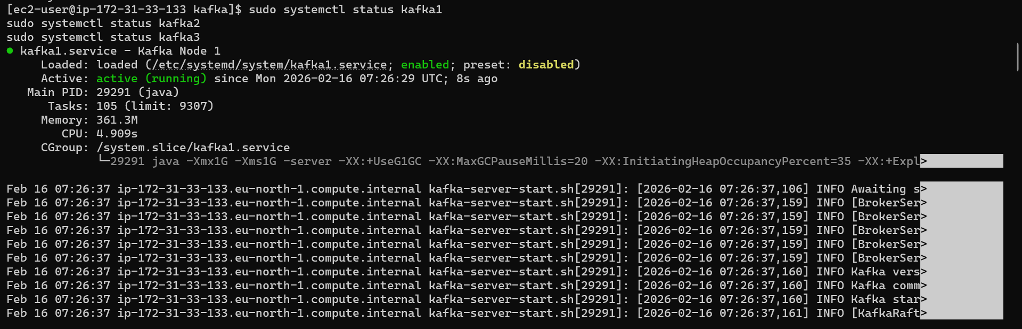
Command:
Check all brokers:
/opt/kafka/bin/kafka-broker-api-versions.sh --bootstrap-server localhost:9092

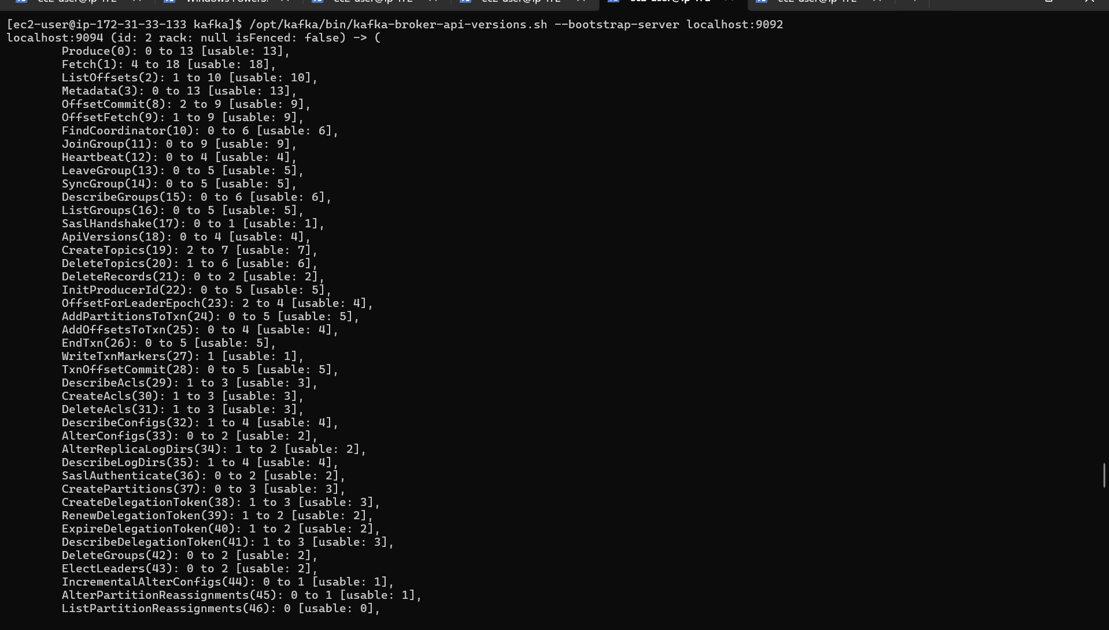
Check who is leader:
/opt/kafka/bin/kafka-metadata-quorum.sh \
--bootstrap-server localhost:9092 describe --status
Create a test topic
/opt/kafka/bin/kafka-topics.sh \
--bootstrap-server localhost:9092 \
--create \
--topic test-topic \
--partitions 3 \
--replication-factor 3

Produce & consume
/opt/kafka/bin/kafka-console-producer.sh \
--bootstrap-server localhost:9092 \
--topic test-topic

In another terminal
/opt/kafka/bin/kafka-console-consumer.sh \
--bootstrap-server localhost:9092 \
--topic test-topic --from-beginning

